EOF (End of File)
Definition:
# Source: AI Source: Provided by: [Data Path: Persons Table -> ID Column: 1, Name_En Column: Motasem Essam] -> From: [Chatgpt (GPT‑5 Mini)] on [1/26/2026]
EOF (End of File) is a special marker used by programs to indicate that there is no more data left to read from a file. It signals that the end of the file has been reached.

Key Points
# Source: AI Source: Provided by: [Data Path: Persons Table -> ID Column: 1, Name_En Column: Motasem Essam] -> From: [Chatgpt (GPT‑5 Mini)] on [1/26/2026]
- EOF is not actual data in the file – it’s a condition detected by the program.
- Most programming languages provide a way to check for EOF while reading a file.
- Reaching EOF prevents further reading and helps the program stop reading gracefully.

How It Works
# Source: AI Source: Provided by: [Data Path: Persons Table -> ID Column: 1, Name_En Column: Motasem Essam] -> From: [Chatgpt (GPT‑5 Mini)] on [1/26/2026]
- When a program reads a file sequentially, it keeps reading until the EOF marker is detected.
- After EOF is reached, any further read attempts fail or return a special value (like -1 in C).

Example in C
# Source: AI Source: Provided by: [Data Path: Persons Table -> ID Column: 1, Name_En Column: Motasem Essam] -> From: [Chatgpt (GPT‑5 Mini)] on [1/26/2026]
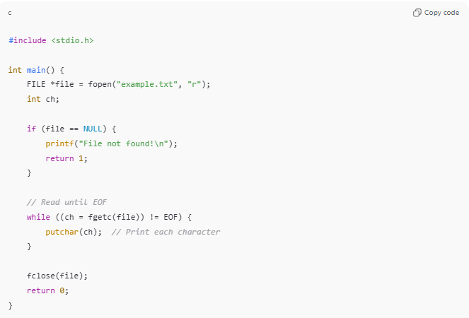
#include <stdio.h>

int main() {
FILE *file = fopen("example.txt", "r");
int ch;

if (file == NULL) {
printf("File not found!\n");
return 1;
}

// Read until EOF
while ((ch = fgetc(file)) != EOF) {
putchar(ch); // Print each character
}

fclose(file);
return 0;
}
- Here, fgetc(file) reads one character at a time until EOF is reached.
- EOF tells the loop to stop reading.

Example in Python
# Source: AI Source: Provided by: [Data Path: Persons Table -> ID Column: 1, Name_En Column: Motasem Essam] -> From: [Chatgpt (GPT‑5 Mini)] on [1/26/2026]
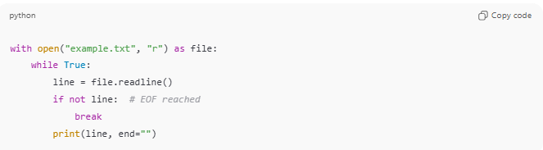
with open("example.txt", "r") as file:
while True:
line = file.readline()
if not line: # EOF reached
break
print(line, end="")
- In Python, an empty string ("") signals EOF when reading a file.

Analogy
# Source: AI Source: Provided by: [Data Path: Persons Table -> ID Column: 1, Name_En Column: Motasem Essam] -> From: [Chatgpt (GPT‑5 Mini)] on [1/26/2026]
- File → A book
- Reading → Going through pages
- EOF → Last page of the book → no more pages to read

✅ Summary
# Source: AI Source: Provided by: [Data Path: Persons Table -> ID Column: 1, Name_En Column: Motasem Essam] -> From: [Chatgpt (GPT‑5 Mini)] on [1/26/2026]
- EOF = End of File marker
- Indicates no more data to read
- Used in loops and file reading operations to stop gracefully

